Recipe rembel

USER GUIDE

|  |  |  |
| --- | --- | --- |
| **Supervisor** | Sir Maaz Ul Haq | |
| **Batch Code** | 2302F1 | |
| **Group** | “B” | |
| **Serial No.** | **Enrollment No.** | **Student Name** |
| 1. | Student1449229 | TUBA ANSARI |
| 2. | Student 1449281 | MARYAM HASEEB |
| 3. | Student 1451081 | SYEDA AYESHA KALEEM |
| 4. | Student 1452705 | MUHAMMAD ISHRAN |
| 5. | Student 1451295 | MUHAMMAD SALMAN ALI KHAN |

Recipe Rembel

**Home Page**

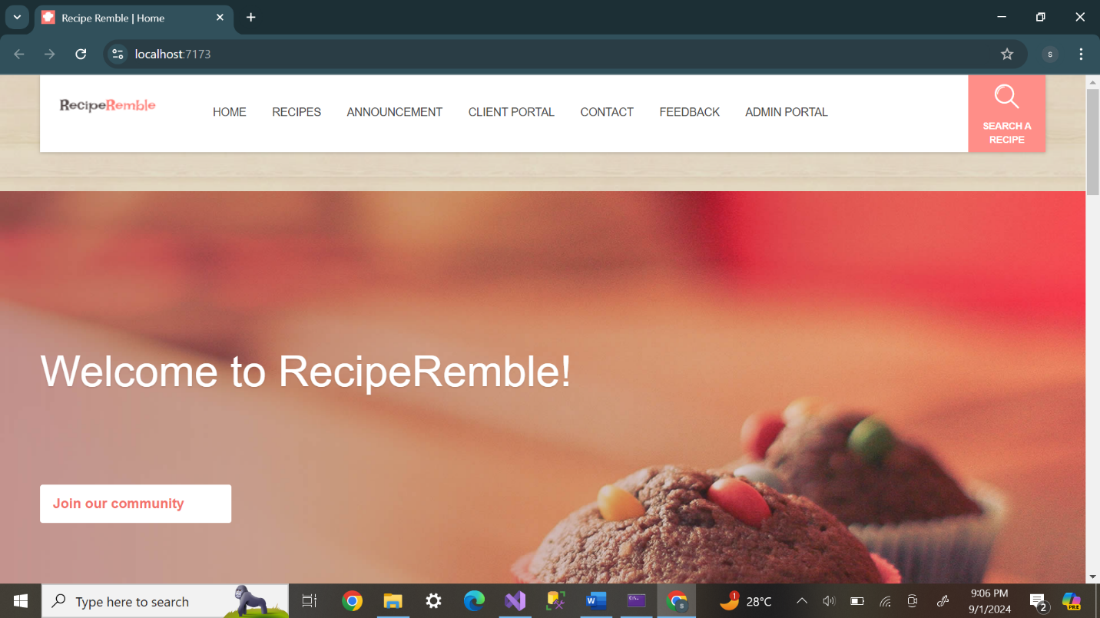

***Register page***

**Our Gallery**

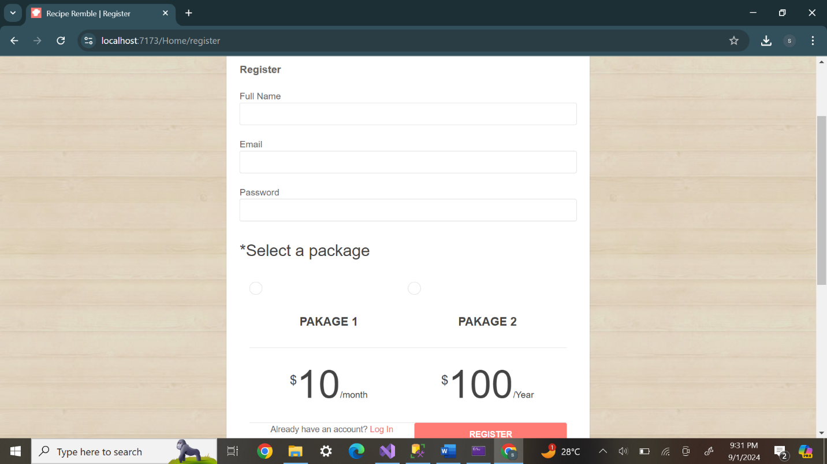

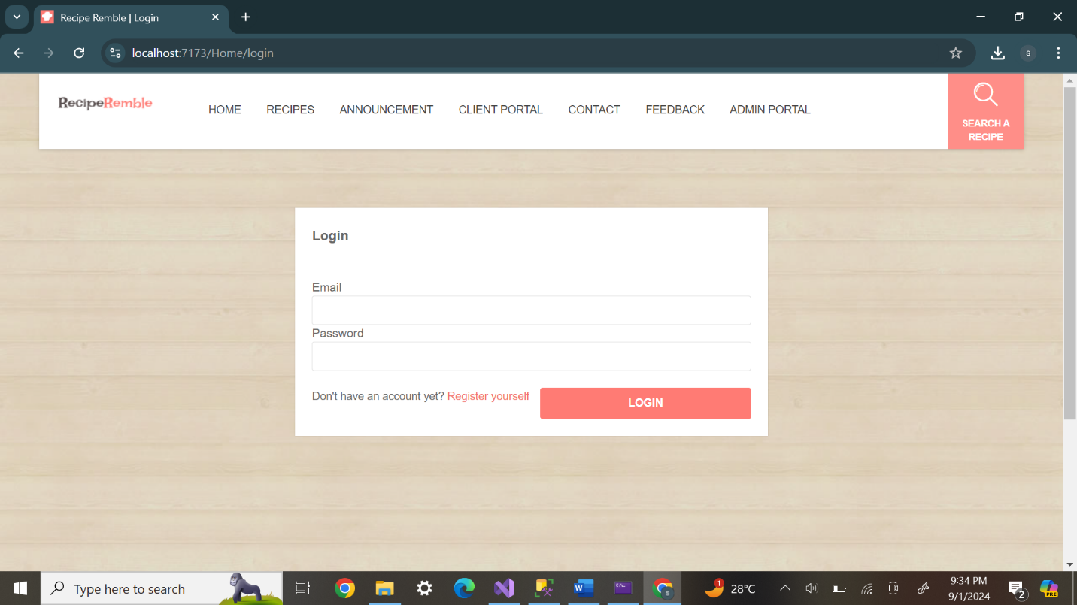***Login Page***

***Contact Us***

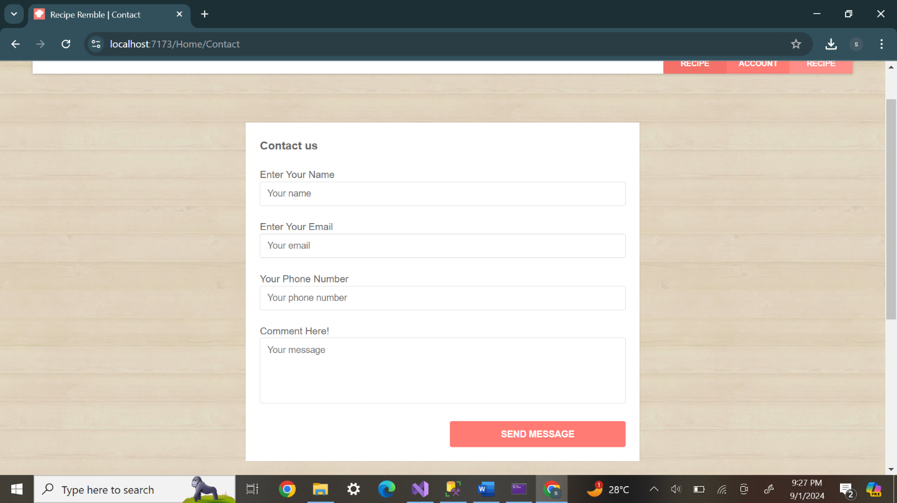

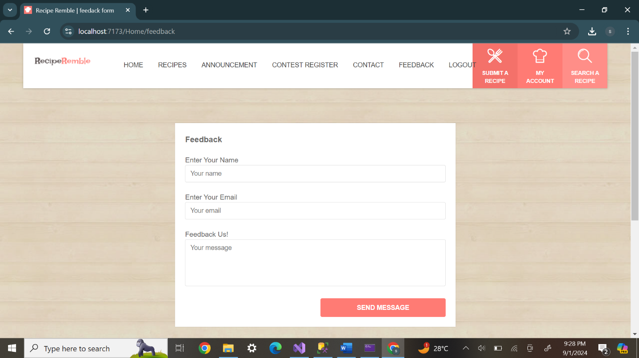***Feedback Form***

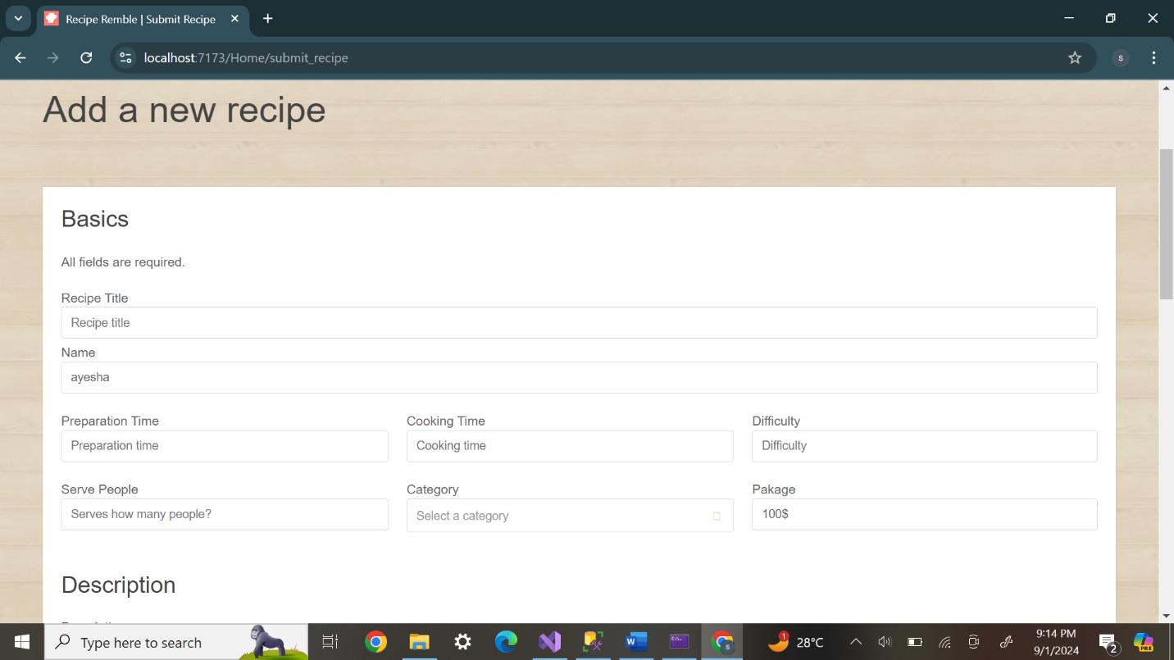**Submit Recipe**

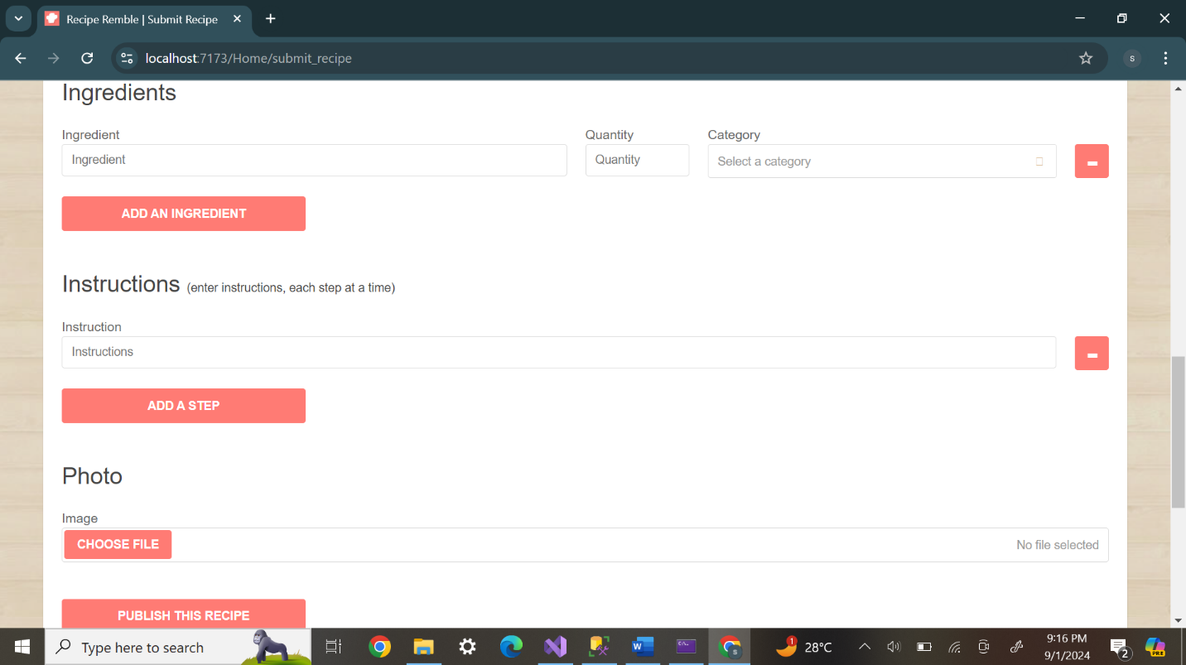**Our Recipe**

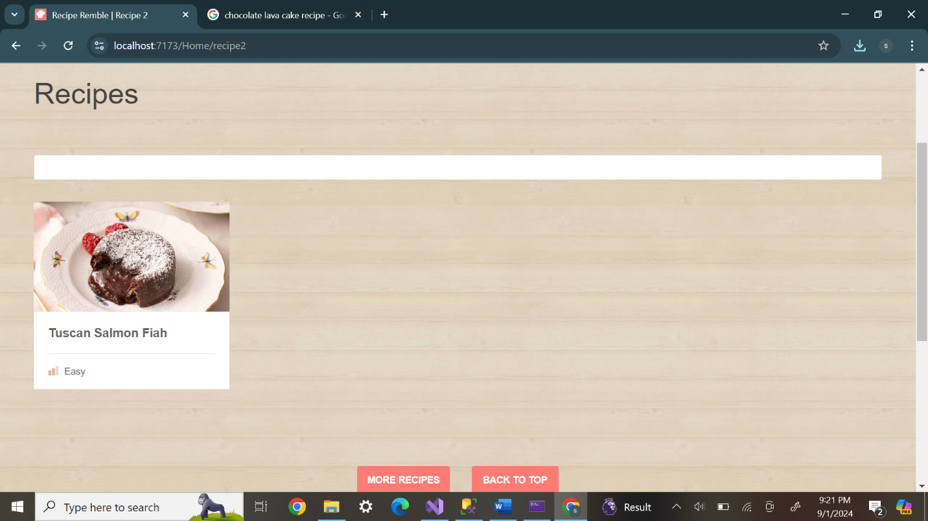

***My account***

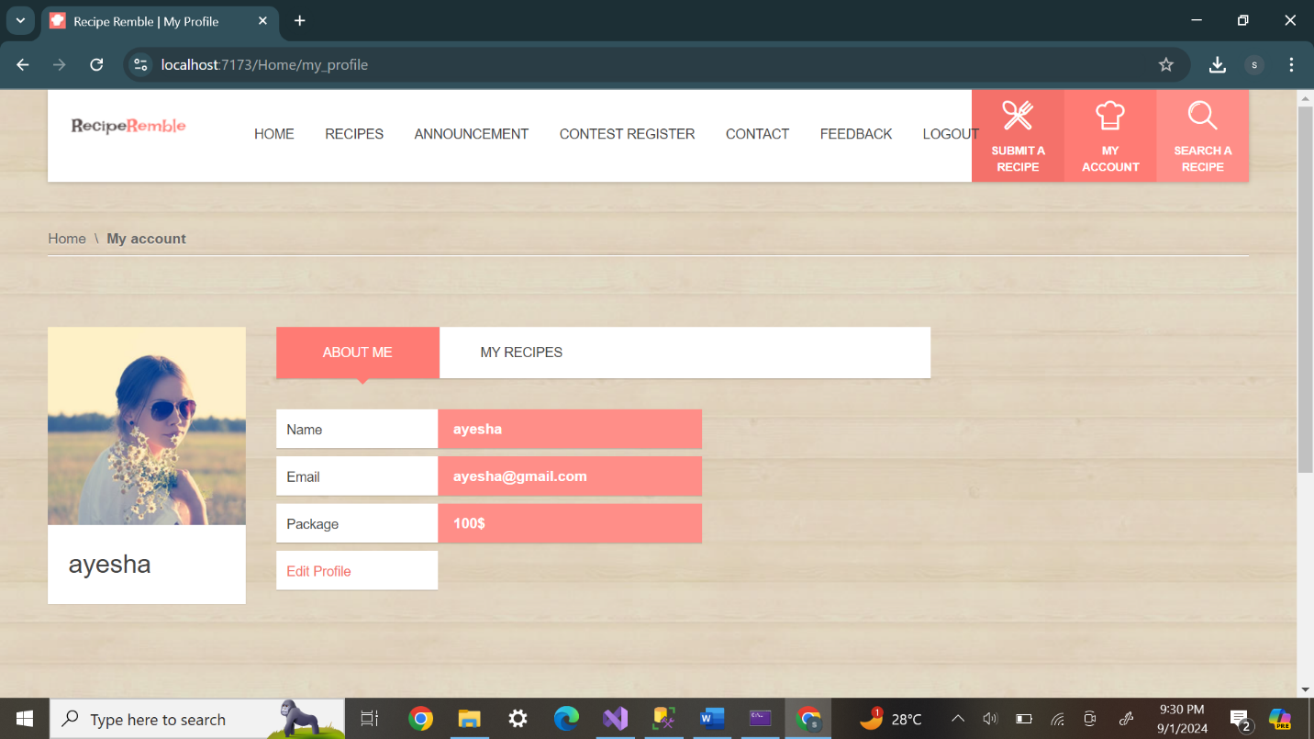***My Account***

***Announcement Page***

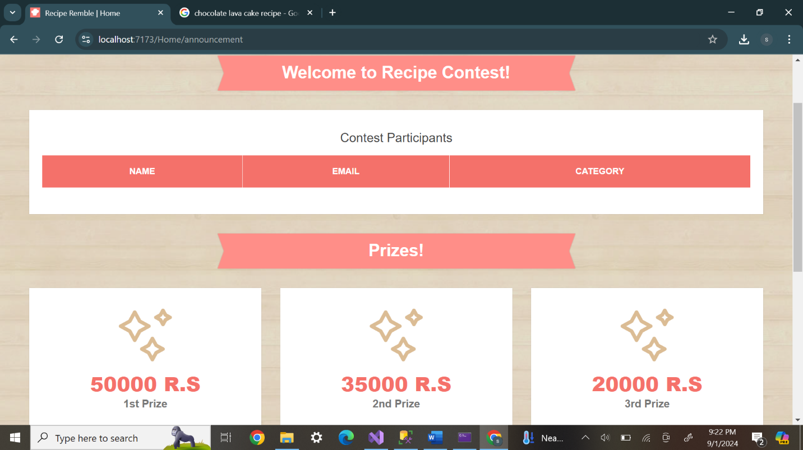

***Contest Register***

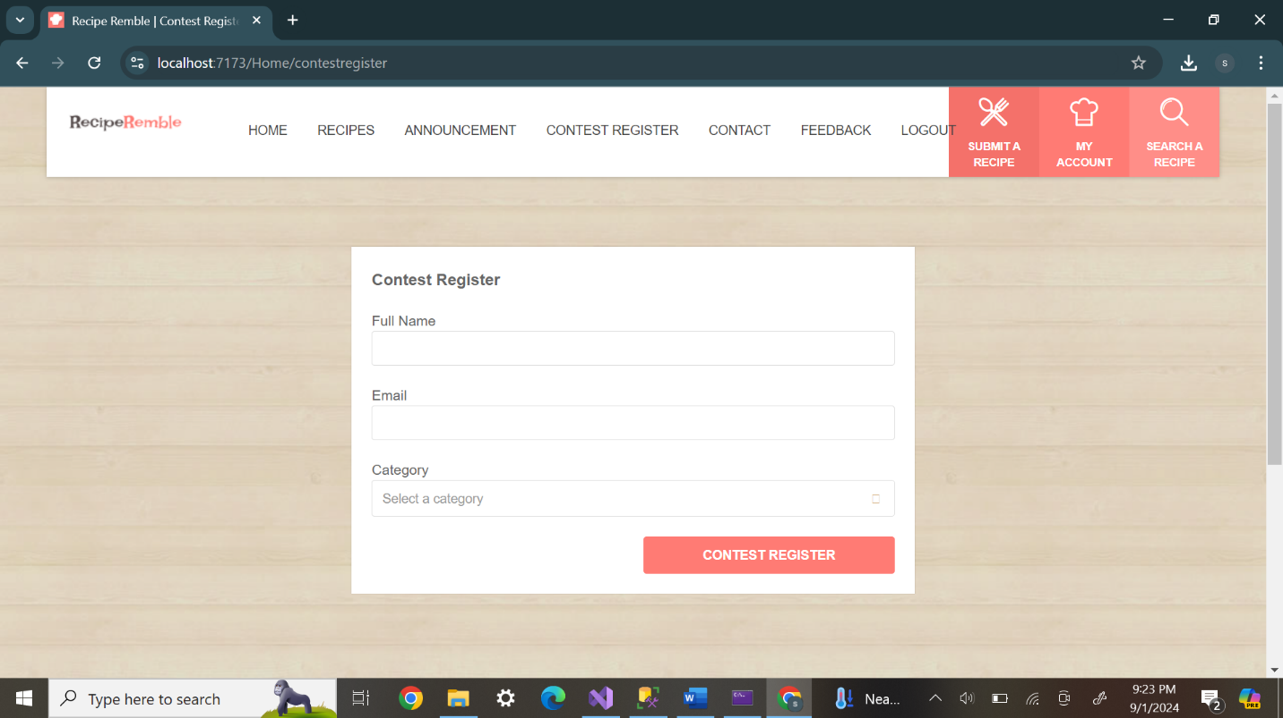

**Admin Portal**

**Register Page**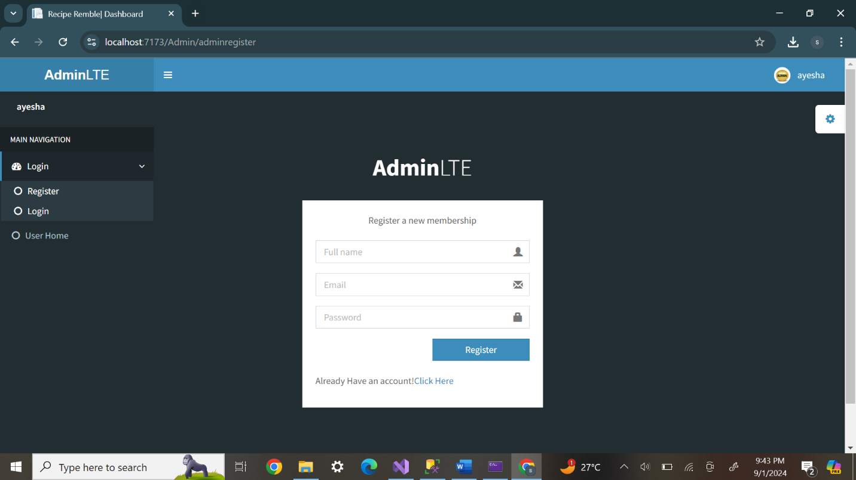

***Login Page***

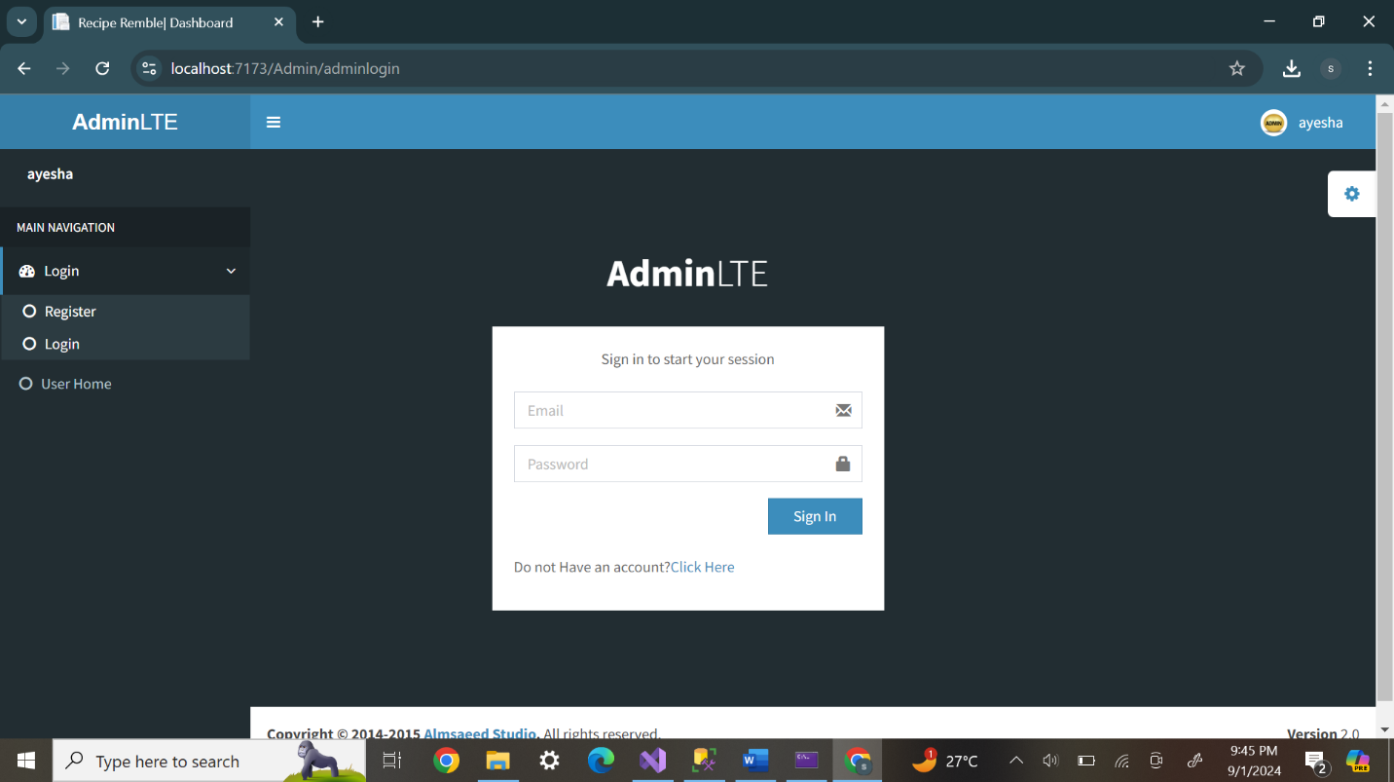

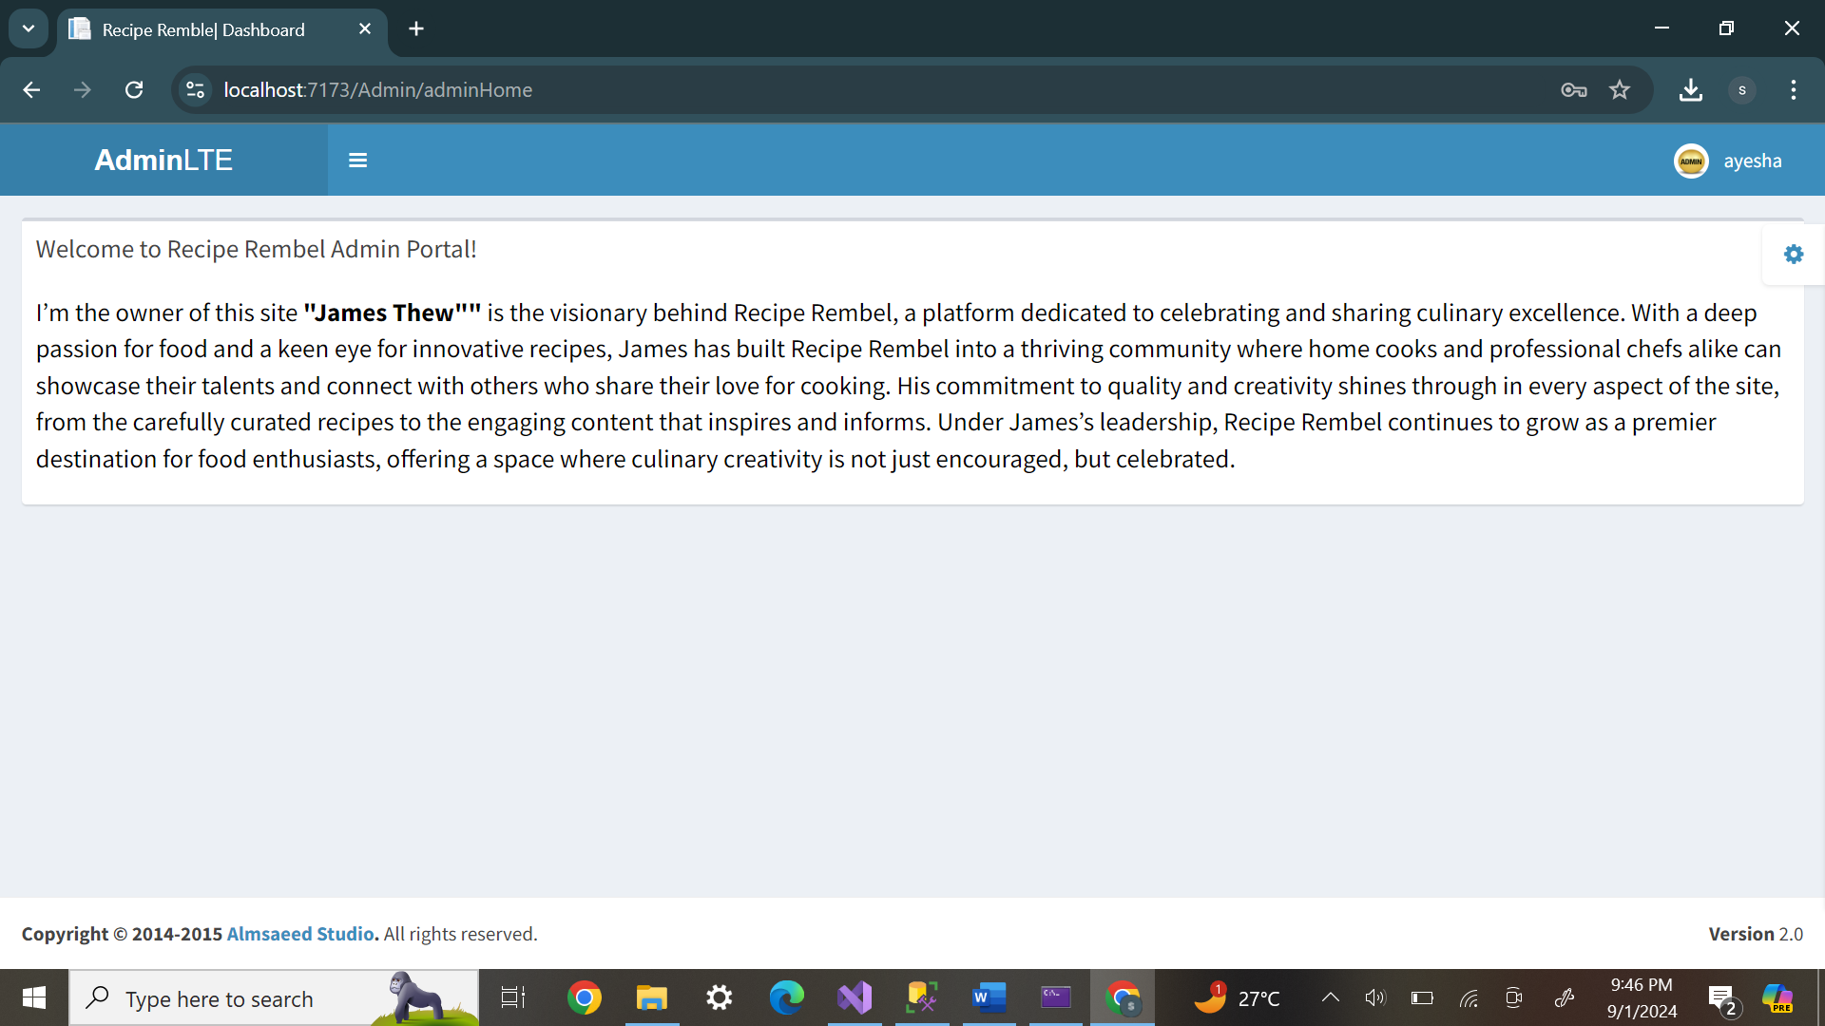

***User Data***

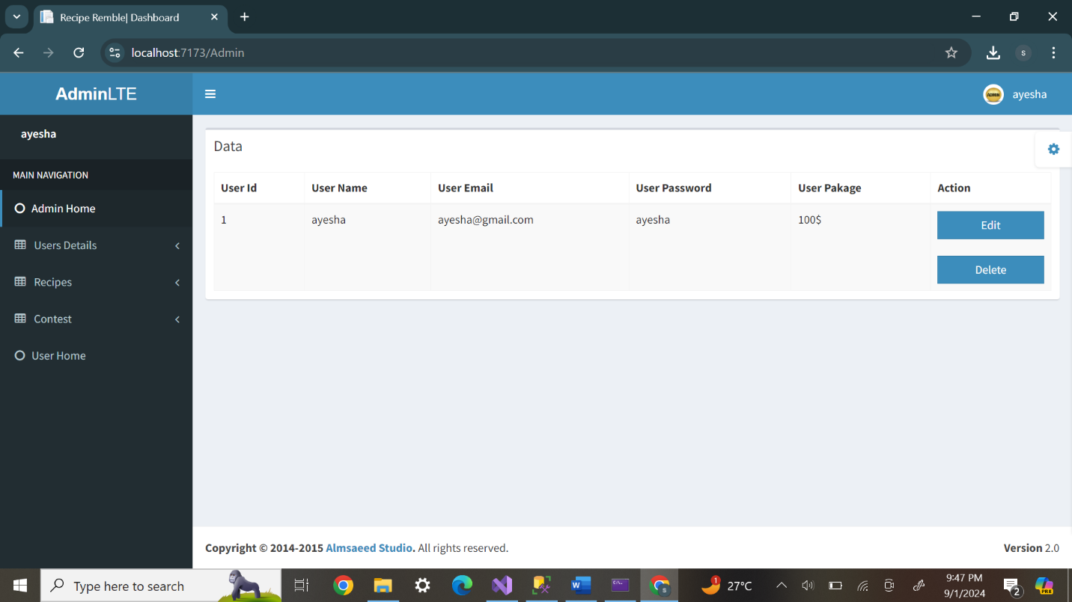

***User Feedback***

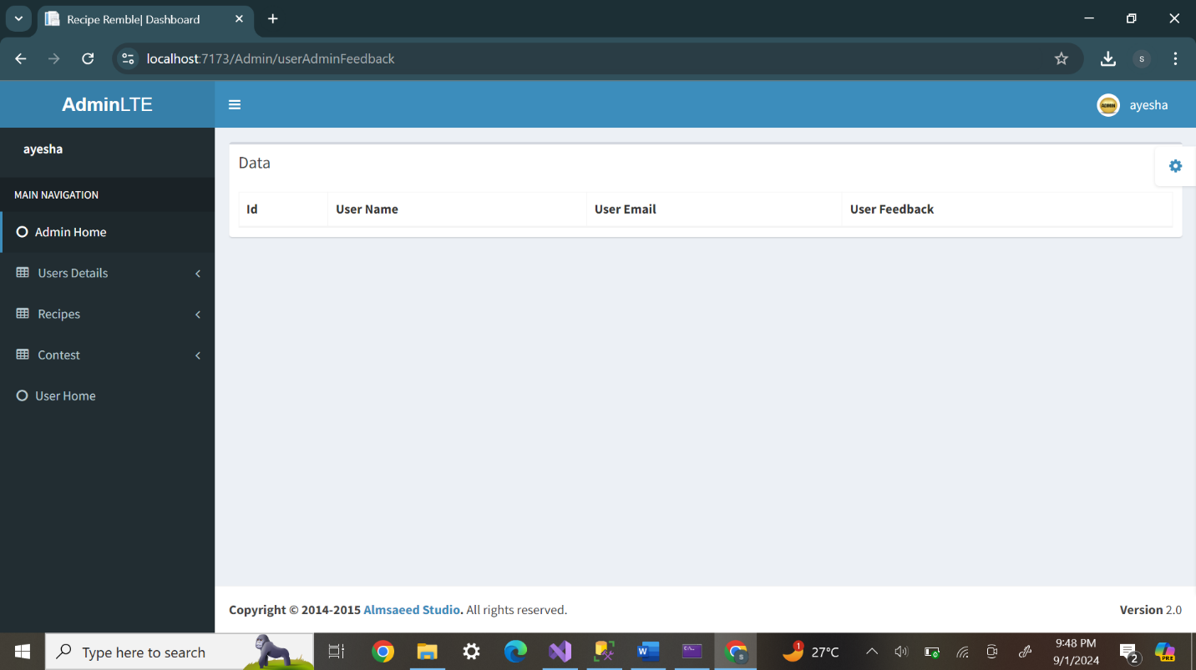

***User Contact***

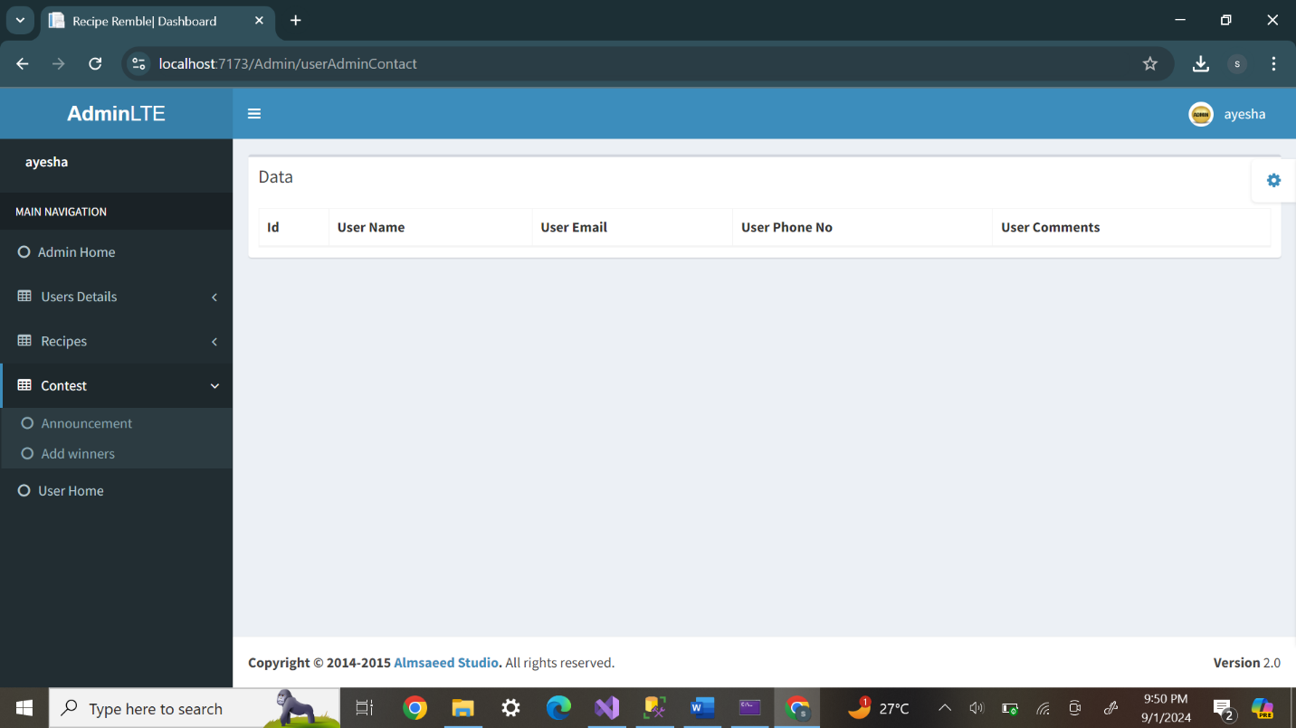

**Admin Recipe**

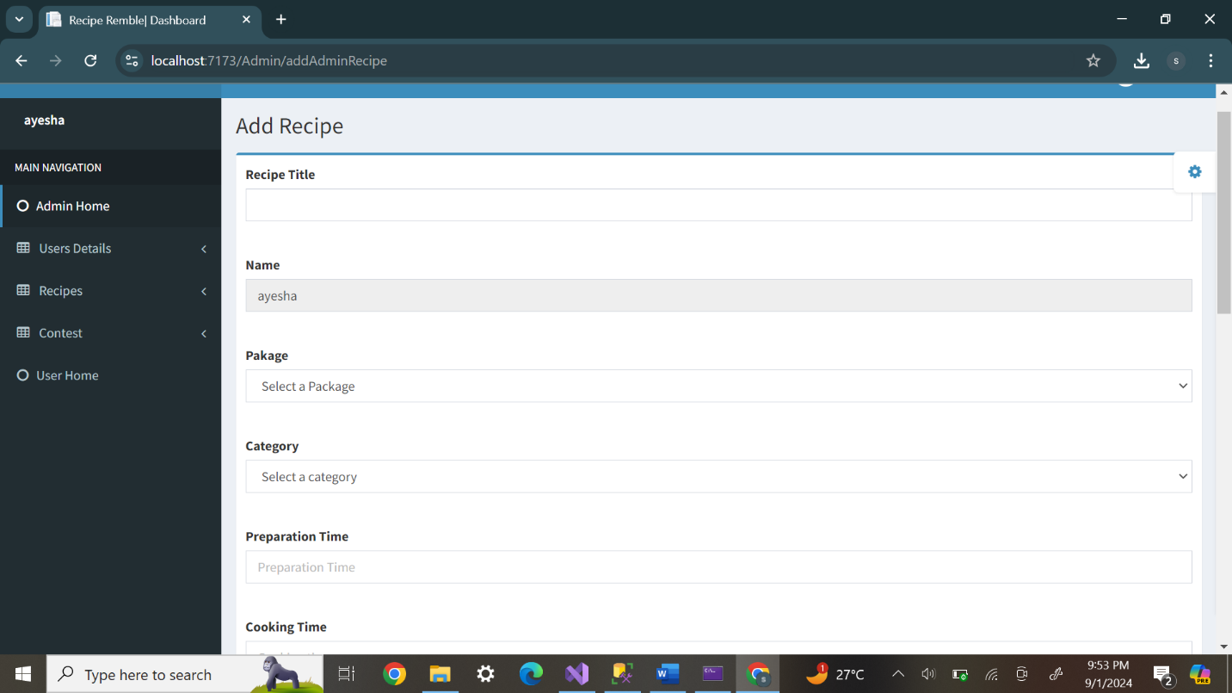

**Contest Participant/winner**

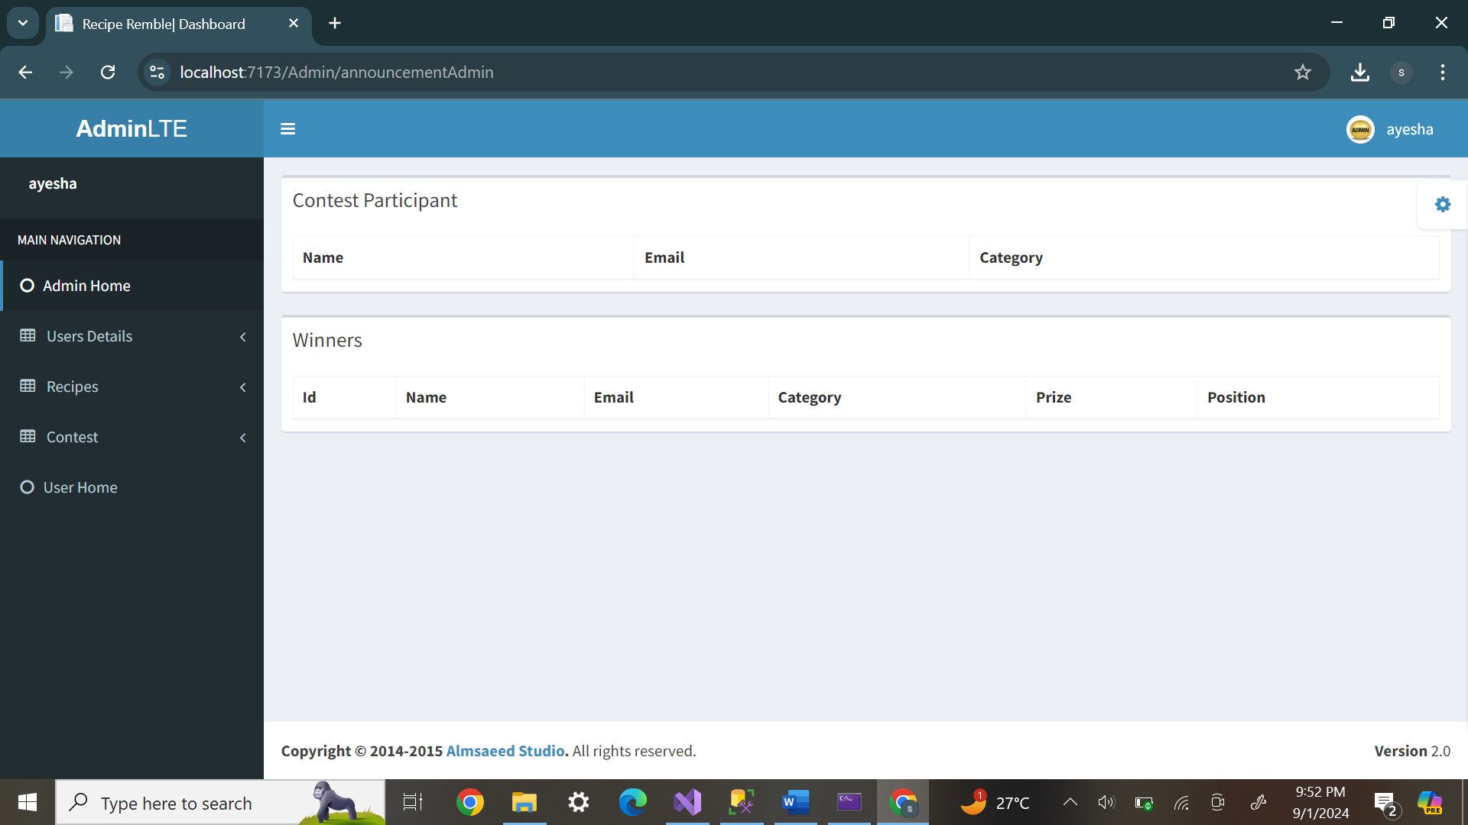

TASK SHEET REVIEW 1

|  |  |  |  |  |  |  |
| --- | --- | --- | --- | --- | --- | --- |
| **Project Ref No.: e/ Advertisement Portal Management System/01** | | **Project Title** | **Date of Preparation of Activity Plan** | | | |
| **NO.** | **TASK** | **Recipe Rembel** | **Actual Start Date** | **Actual Days** | **Team-mates Name** | **Status** |
| 1. | Build Home Page | 01-08-2024 | 1 | Tuba Ansari | Completed |
| 2. | Build recipe, submit recipe page | 02-08-2024 | 5 | Tuba Ansari,  Syeda Ayesha kaleem, Maryam Haseeb | Completed |
| 3. | Build Contact Page | 08-08-2024 | 2 | Syeda Ayesha kaleem | Completed |
| 4. | Build Announcement Page | 10-08-2024 | 2 | Maryam Haseeb, | Completed |
| 5. | Build Client Portal Page |  | 12-08-2024 | 2 | Maryam Haseeb | Completed |
| 6. | Build Admin Portal Page |  | 14-08-2024 | 3 | Tuba Ansari,  Syeda Ayesha kaleem | Completed |

TASK SHEET REVIEW 2

|  |  |  |  |  |  |  |
| --- | --- | --- | --- | --- | --- | --- |
| **Project Ref No.: e/ Advertisement Portal Management System/01** | | **Project Title** | **Date of Preparation of Activity Plan** | | | |
| **NO.** | **TASK** | **Recipe Rembel** | **Actual Start Date** | **Actual Days** | **Team-mates Name** | **Status** |
|  |  |  |  |  |  |
| 1. | Check color, code, format | 16-08-2024 | 1 | Tuba Ansari,  Maryam Haseeb,  Syeda Ayesha kaleem, | Completed |
| 2. | Check color, code, format  recipe page & recipe submit | 17-08-2024 | 4 | Tuba Ansari,  Maryam Haseeb,  Syeda Ayesha kaleem | Completed |
| 3. | Check color, code, format  Responsive in website, support, code images, register,  admin | 21-08-2024 | 3 | Tuba Ansari,  Maryam Haseeb,  Syeda Ayesha kaleem | Completed |
| 4. | Write a developer guide | 22-08-2023 | 2 | Tuba Ansari,  Maryam Haseeb,  Syeda Ayesha kaleem | Completed |
| 5. | Write user | 25-08-2023 | 2 | Tuba Ansari,  Maryam Haseeb,  Syeda Ayesha kaleem, | Completed |
| 6. | Overall inspection of the project | 27-08-2023 | 3 | Tuba Ansari,  Maryam Haseeb,  Syeda Ayesha kaleem, | Completed |